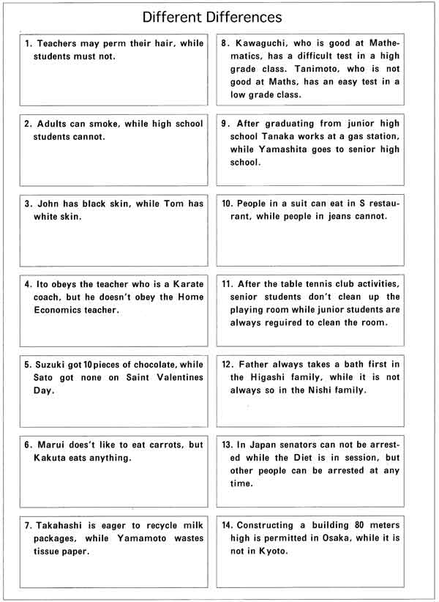

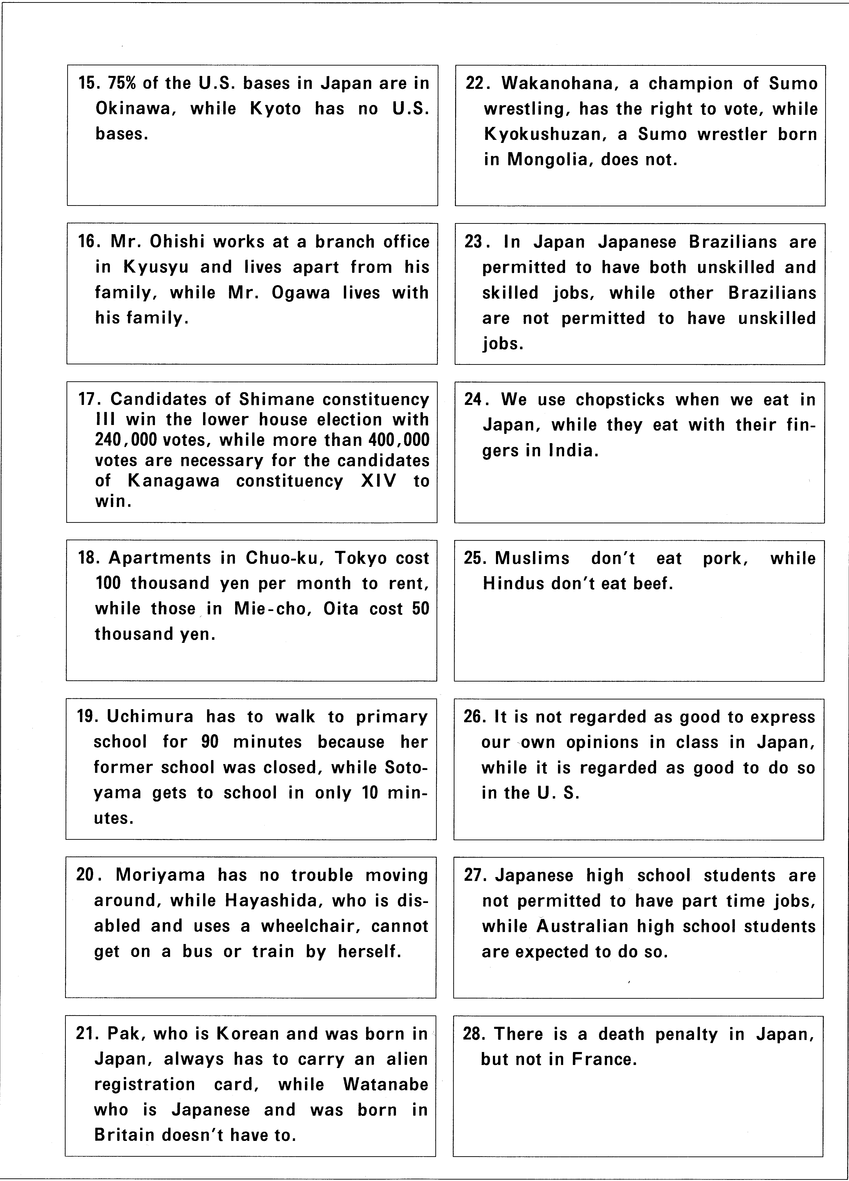

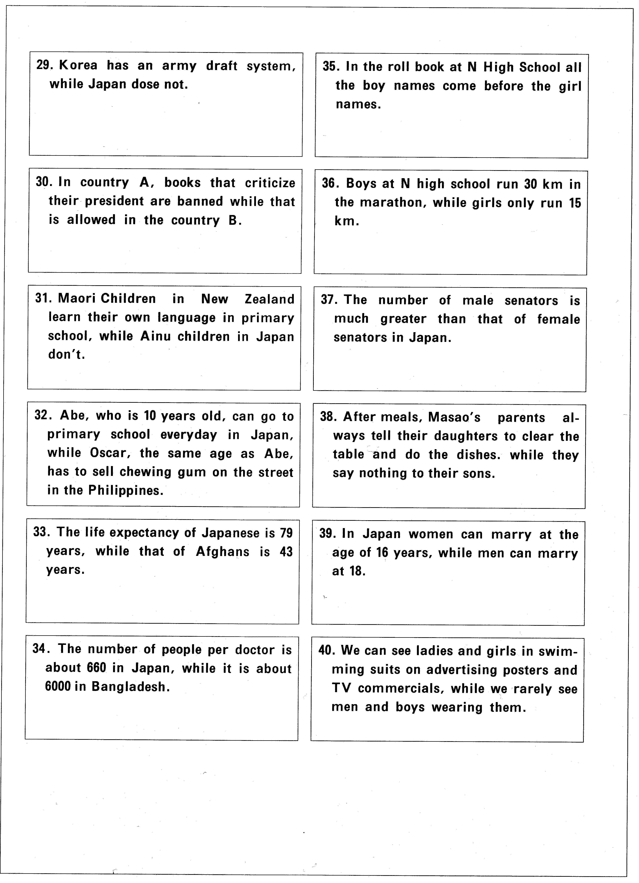

Language Focus
Different Differences: from real high school students:
Can you guess the word? A…Alo…Allowed! Etc.
1) Homeless people aren’t (__________) to live in the park, but birds and other living things (__________).
2) Being a housewife is (__________) normal, but being a stay-at-home dad is not
3) People in the U.S. can buy guns, but you (__________) in Japan.
4) Killing a person is a (__________), killing a worm isn’t.
5) Many companies won’t (__________) women older than 30.
6) People who work in the (__________) sector (city-hall, policemen) are never fired.
7) Student from school A can come (__________) bike, but they can’t in school B.
8) Girls and boys are (__________) in P.E. class.
9) Mr./Ms. A (__________) from high school and can get a job, but Mr./Ms. B didn’t and can’t.
10) People in the U.S. can’t drink (__________) they are 20, but they can drink at 19 in Canada.
11) Boys can (__________) the baseball team, but girls can’t.
12) Part-time workers (__________) paid less than full-time workers.
13) Some people get fat (__________) than others.
14) My teacher (__________) girls different than boys.
15) In Holland, soft drugs are (__________), but they are not in Japan.
16) Some students are (__________) (__________) (__________) if they are small.
17) Club A forces members to practice, but members from club B can (__________) if they want.
18) Boys are made to do (__________) labor in preparation for the sports festival, but girls aren’t.
19) A was (__________) by the police, but was freed because he paid a lot of money.
20) They have (__________) day at the video shop, but no men’s day.
21) Teachers aren’t (__________) when late for class, but students are.
22) Junior high school students can’t (__________) their cell-phones to class, but HS students can.
23) Children can’t go (__________) late at night but adults can.
24) 18 year-olds can get a part-time (__________), but 17 year-olds can’t,
25) China is a (__________) member of the UN Security council, but Japan isn’t.
26) There are ladies-(__________) train cars, but no men-only train cars.
27) In class, student A has a good (__________), but student B doesn’t.
28) Older children are (__________) more money for ‘otoshidama’.

From real high school students:
1. Homeless people aren’t allowed to live in the park, but birds and other living things are.
2 Being a housewife is considered normal, but being a house-husband is not
3 People in the U.S. can buy guns, but you can’t in Japan.
4 Killing a person is a crime, killing a worm isn’t.
5 Many companies won’t hire women older than 30.
6 People who work in the public sector (city-hall, policemen) are never fired.
7 Student from school A can come by bike, but they can’t in school B.
8 Girls and boys are separated in P.E. class.
9 Mr./Ms. A graduated from high school and can get a job, but Mr./Ms. B didn’t and can’t.
10 People in the U.S. can’t drink until they are 20, but they can drink at 19 in Canada.
11 Boys can join the baseball team, but girls can’t.
12 Part-time workers get paid less than full-time workers.
13 Some people get fat easier than others.
14 My teacher treats girls different than boys.
15 In Holland, soft drugs are legal, but they are not in Japan.
16 Some students are made fun of if they are small.
17 Club A forces members to practice, but members from club B can skip if they want.
18 Boys are made to do manual labor in preparation for the sports festival, but girls aren’t.
19 A was arrested by the police, but was freed because he paid a lot of money.
20 They have lady’s day at the video shop, but no men’s day.
21 Teachers aren’t scolded when late for class, but students are.
22 Junior high school students can’t bring their cell-phones to class, but HS students can.
23 Children can’t go outside late at night but adults can.
24 18 year-olds can get a part-time job, but 17 year-olds can’t,
25 China is a permanent member of the UN Security council, but Japan isn’t.
26 There are ladies-only train cars, but no men-only train cars.
27 In class, student A has a good seat, but student B doesn’t.
28 Older children are given more money for ‘otoshidama’.

