(C) Group activity: Which problems are ‘root causes’?
Name:
*Use arrows!
* You don’t need to use all of the squares.
.

.
.

.

.

.

.

.

.

.

.

.

.

.

Webbing Activity 2: Root Cause Analysis
- Let’s draw the connections together as a class.
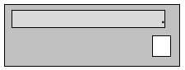

(B) What is the ranking?
score | Causes (upstream) (sickness)
 | Effects (downstream) (symptom)

