1) Sustainability means being able to continue to do something ( )
2) As you can see below there are three basic dimensions: ( )
3) In a country like Kenya creating sustainability could mean ( )
4) 'Sustainable development' cannot be achieved if ( )
5) Biofuels are usually made from ( )
6) Biofuels aren’t bad for global warming ( )
7) There are endless ( )
(A) something like what Wangari Maathai's group GBM does by planting trees and empowering women.
(B) plants
(C) possibilities for what you may consider an issue of sustainability..
(D) globalization and economic growth end up destroying nature and increasing poverty
(E) social, environmental, and economic.
(F) without causing damage.
(G) because the plants reduce the same amount of CO2 as they make.
Match the parts of the sentences:

Write about the topic you are considering:
Name________________________________Student/Class Number__________

Sustainability
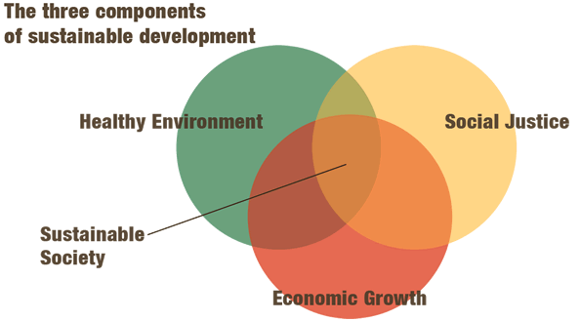
Match the words with the definitions.

- sustainability
- social
- environmental
- economic
- GBM
- Palestine
- MDGs
- poverty
- global warming
- to have promise

A) [__________________________] = This means things about people.
B) [__________________________] = This is happening because we burn too much fossil fuel and put CO2 in the atmosphere.
C) [__________________________] = This means things concerning money. or trade.
D) [__________________________] = These are the 8 goals set by the UN in the year 2000.
E) [__________________________] = This means to have a good chance of success.
F) [__________________________] = This means to be able to do something now without destroying things in the future.
G) [__________________________] = This means not having enough money for your basic needs.
H) [__________________________] = This is the name of Wangari Maathai’s group that planted trees and helped women.
I) [__________________________] = This means things concerning nature.
J) [__________________________] = This is the country controlled by Israel. The people want their own country back.

